1.Waht is the diff b/w Primary key and Unique Key?

|  |  |  |
| --- | --- | --- |
| **S.L** | **Primary Key** | **Unique Key** |
|  | Primary key Cannot Accept Null Values. | Unique Key Can Accept Only Null Value. |
|  | Creates Clustered Index | Creates Non-Clustered Index |
|  | Only One Primary Key in a Table | More than one Unique Key in a Table |

2. What is Triggers and Types of triggers?

Triggers are stored programs, which are AUTOMATICALLY executed or fired when some events (insert, delete and update) occur.

3. What is the difference between Having clause and Where clause?

WHERE Clause is used before GROUP BY Clause. HAVING Clause is used after GROUP BY Clause.

WHERE Clause cannot contain AGGREGATE Function. HAVING Clause can contain AGGREGATE Function.

4. What is Sub Query or Nested Query or Inner Query in SQL?

A Subquery or Inner query or Nested query is a query within another SQL query and embedded within the WHERE clause.

5. What is Auto Increment/Identity column in SQL Server?

Autoincrement allows a unique number to be generated automatically when a new record is inserted.

6. What are Joins in SQL? Types

A Join clause is used to combine rows from two or more tables, based on a related column between them.

* 1. Left Outer Join
  2. Right Outer Join
  3. Full Outer Join
  4. Inner Join
  5. 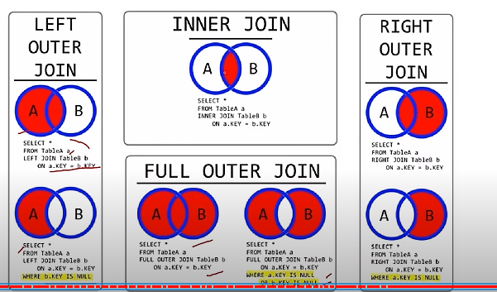

7. What is Self-join?

A Self Join is a Join of a table to itself.

8. What are Indexes in SQL Server?

SQL Indexes are used in relational databases to retrieve data VERY FAST.

9.What is clustered Index in SQL Server?

A Clustered index defines the order in which data is physically stored in a table.

Table data can be stored in only way, therefore, there can be only one clustered index per table.

10. What is Non- clustered Index in SQL Server?

A Non-Clustered index is stored at one place and table data is stored in another place. So this index is not physically stored. Table can have multiple non-clustered indexes in a table.

11. What is the diff b/w Stored procedure and Functions?

|  |  |
| --- | --- |
| **Stored Procedure** | **Function** |
| SP may or may not return a value | Function must return a value |
| SP Can have input/output parameters | Function only has input parameter |
| We can call function inside SP | Cannot call SP from a Function |
| We cannot use SP in SQL statements like SELECT, INSERT, UPDATE, DELETE, MERGE, etc. | We can use in SQL statements like SELECT, INSERT, UPDATE, DELETE, MERGE within function. |
| We can use try-catch exception handling in SP | We cannot do try-catch exception handling in function |
|  |  |

12. How to optimize a Stored Procedure or SQL Query?

1. Use SET NOCOUNT ON

2. Specify column names instead of using * in SELECT Statement.

3. Use schema name before objects or tablenames. Ex: SELECT EmpID, Name From dbo.Employee.

4. Do not use DYNAMIC QUERIES. They are vulnerable to SQL Injections.

5. Use EXISTS () instead of Count ().